**Assignment 4 - Move Paddles**

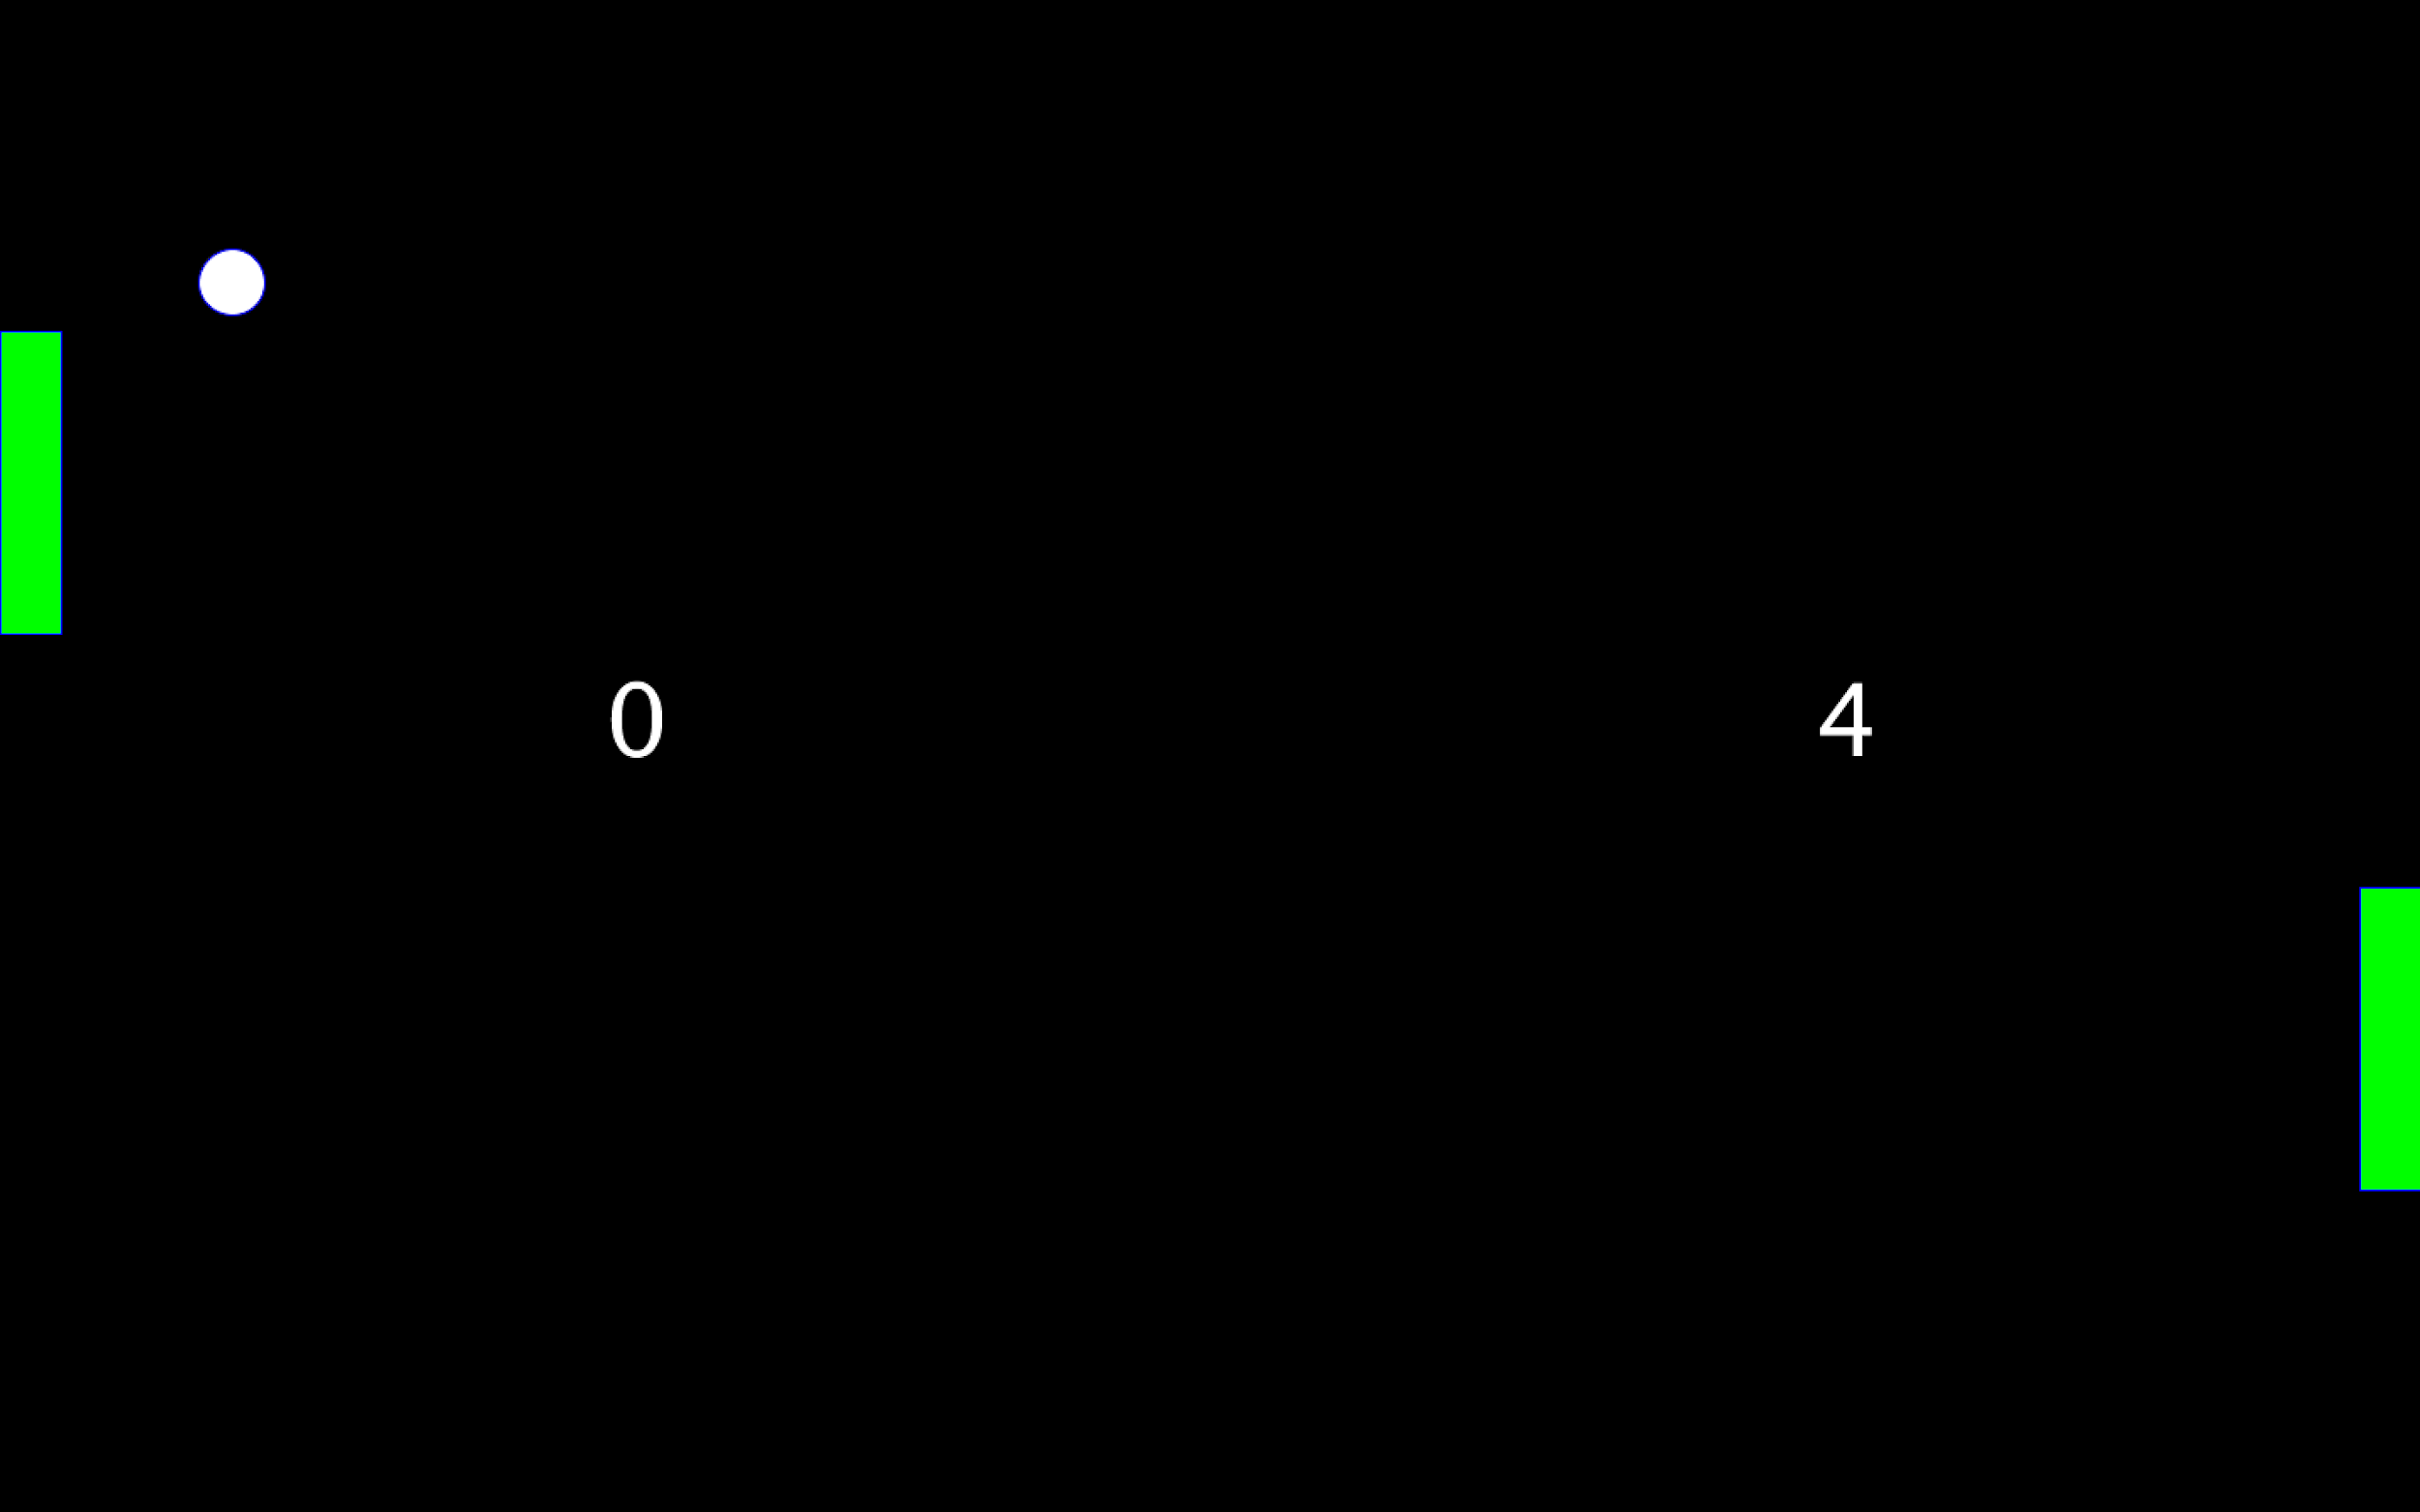

***Note:*** *If you haven’t done so already, go through Lesson: “4.0 Functions” and complete “Quiz 4” first before attempting this assignment*

**Goal**

This assignment requires you to use the knowledge from Lesson 4 about functions to move the paddles, make the ball bounce off the paddles, and put the whole Pong game together.

**Instructions**

**Code Setup**

Do the following steps carefully. **Note that failure to do so would result in getting a grade of zero for this assignment because AutoGrad won’t be able to grade your work!**

1. Open the program Assignment4, and rename both 1) the program and 2) the tab by adding “**_”** andyour student id at the end like “Assignment4_sa321” as shown in “Course Apps Setup” page 12 and 13. You can get your student id by going to [this link](http://suacode.netlify.app), entering the course id (sa002), and the email you used to sign up for Piazza.
2. Put your ***maxX*** and ***maxY*** values in the comment at the top of the code by replacing the *** with your values.
3. Copy relevant parts of code from Assignment3 and into Assignment4 as needed to implement the assignment specifications
4. Make sure the ***fullScreen()*** function is within your ***setup()*** function.

**Assignment Specifications (specs)**

Write a program that allows you to move the Pong paddles and also makes the ball bounce off the paddles using the following instructions:

1. Move Paddles: Write the function below and call it in ***draw()***
   * ***movePaddles()*** 
     + Move the left paddle when touching the left part of the screen and moves right paddle when touching the right part of the screen
     + Move the paddles up or down when screen touch moves up or down
     + Make sure the paddles do not leave the screen!

**Hint**: Look at function ***movePaddle()*** in the program ***move_paddle***

1. Check Paddle: Write the 2 functions below and call them in ***draw()***
   * ***checkLeftPaddle()***
     + Make the ball bounce off left paddle

**Hint:** Use the function ***doesOverlap()*** from the program ***ball_overlaps_paddle***

* + ***checkRightPaddle()*** 
    - Make the ball bounce off right paddle
    - **Hint:** Use the function ***doesOverlap()*** from the program ***ball_overlaps_paddle***

1. Create the following functions by organizing and using the code that you’ve already written in Assignment 3. Make sure to call them in ***draw()***
   * ***displayScores()*** 
     + Draws the scores on the screen
   * ***displayBall()*** 
     + Draws the ball on the screen
   * ***displayPaddles()*** 
     + Draws the paddles on the screen
   * ***moveBall()*** 
     + Moves the ball if the game is on
   * ***checkWall()*** 
     + Makes the ball bounce off the top and bottom walls,
     + Increments left player’s score if ball hits right wall and increment right player’s score if ball hits left wall.
     + Sets the game off if it hits the left or right wall.
   * ***setGameMode()***
     + Sets game on if mouse is pressed
2. As always, use descriptive variable names (no magic numbers), add comments to your code, indent your code properly and group similar code together
3. Take a screenshot of your program’s output after running, eg. paddles moved, ball bounced off paddle

**Extra Credit: Optional Project**

If you are feeling ambitious, you can try this extra credit work which is the optional project. Make the game more interesting and WOW us with extra features. You will grade each other’s projects and we will use that to select the top 3 games! Hence, to make the game look and feel the same way on the devices of other SuaCoders who will download your app, your variables should be initialized relative to the built- in variables **width** and **height** (eg. int ballX = width/2).

* **Hint:** For this to work,don’t use the combined declaration and initialization approach. Instead, first declare your variables before **setup()** and then **only** initialize them in ***setup()*** below ***fullScreen().***

Make sure to submit a write up on the additional features you work on. Make sure you have completed the main assignment instructions before attempting this.

* Create a new Sketch with the name Project_**id**.pde where **id** is your student id
  + You have to move the new Sketch to your Sketchbook before you can rename it
* Go to Sketch Properties -> Locked Orientation and select Landscape
* Copy your Assignment4 code into this Sketch
* Any ideas you can try to make your game cooler using knowledge from the topics in lessons 1,2,3 and 4. Here are some ideas but you are welcome do more or others:
  + Increasing the speed of the ball slightly when it bounces off the paddle
  + Changing the color of the ball randomly as it moves
  + Changing the color of the ball when it bounces off the paddle
  + Varying the size of the ball from its size to zero as it moves
  + Random initial direction for the ball
  + Two or more balls
  + Create game levels which are reached when certain scores are obtained.
  + Adding sound when the ball hits the paddle. [**Link here**](https://bit.ly/sa-sound-lib).
  + After one player scores, restarting the game only after removing your finger from the screen and touching it again. See the **mouseReleased()** function. [Link here](https://bit.ly/mouse-released).
  + Move the paddles when the tilt the phone up and down (see the Accelerometer code in the Examples folder in APDE)
* Export your code as an apk which is the app that gets installed on your Android device when you download an app. [**Link** **here**](https://bit.ly/apde-apk).
* Now you can share your apk file with your friends to install on their phones and play your game!

**Submission**

1. Before submitting your code, make sure your code runs without any errors. Also, make sure you have done everything outlined in the instructions exactly.
2. Submit your assignment at this submission link which will only be available 48 hours before the assignment deadline: [**link here**](https://bit.ly/ass4-form)
   * **NB:** You should still start working on the assignment early as we are using this measure to prevent people from making wrong submissions because they are rushing

**Peer Grading Submission**

If you did the extra credit/optional project and you would like to take part in the peer grading and vie for the top 3 projects, submit your **apk** file using this [**link**](https://bit.ly/sa-peergrade) (available 48 hours before the deadline) and the course code: **3AGEDT**. Peer grading will be possible after the deadline.